PROFLOW - FINAL PROJECT REPORT

Course: BIT
University: The Co-operative University of Kenya
Date: 25/4/2026
Team Members:
- Joshua Akadake (DevOps Lead)
- Lynesophy Mauwa (Backend Developer)
- Derrick Abobo (System Architect)
- Abere Yvette (Full-Stack Developer)
- Wendy Kerubo (Frontend Developer)

1. INTRODUCTION

1.1 Project Overview
ProFlow is a collaborative task management web application that helps teams organize, track, and complete tasks efficiently. The application provides a centralized platform where team members can create tasks, assign them to others, set priorities and due dates, and track progress in real-time.

1.2 Problem Statement
Teams often struggle with poor coordination, scattered communication across multiple platforms (WhatsApp, email), and no central place to track tasks. This leads to missed deadlines, duplicated work, and reduced productivity.

1.3 Objectives
- To develop a web-based task management system
- To implement user authentication and authorization
- To provide task creation, assignment, and tracking features
- To enable team collaboration through comments and assignments
- To deploy the application using Docker containers

2. SYSTEM ARCHITECTURE
2.1 Technology Stack

Frontend: React.js with Tailwind CSS
Backend: Node.js with Express.js
Database: PostgreSQL
Authentication: JWT (JSON Web Tokens)
Containerization: Docker and Docker Compose
Version Control: Git with GitHub
CI/CD: GitHub Actions

2.2 Architecture Diagram

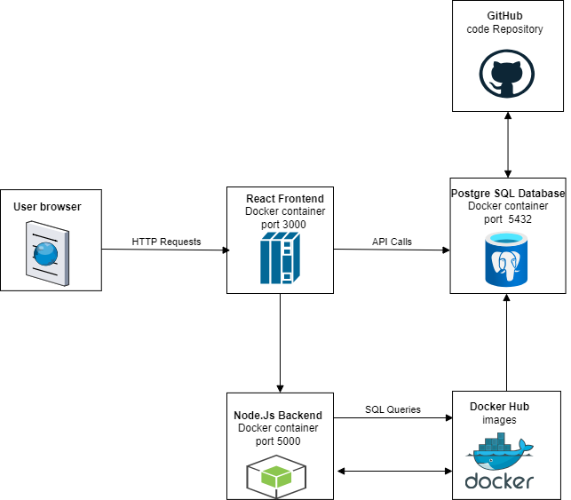

The application consists of three main containers:
- Client Container (React frontend on port 3000)
- Server Container (Node.js backend on port 5000)
- Database Container (PostgreSQL on port 5432)

All containers are orchestrated using Docker Compose with a single command: docker-compose up --build

3. DATABASE DESIGN

3.1 Entity Relationship Diagram (ERD)
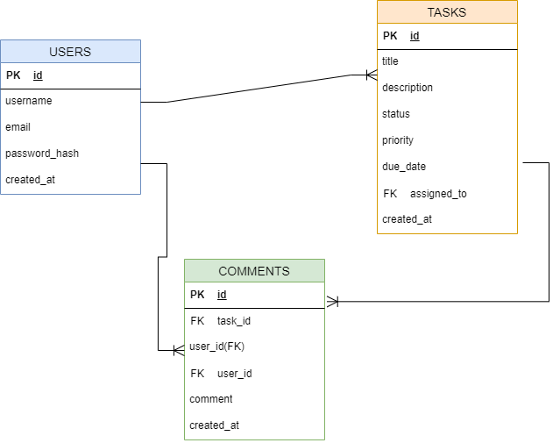

3.2 Tables

Users Table:
- id (Primary Key)
- username (Unique, Not Null)
- email (Unique, Not Null)
- password_hash (Not Null)
- created_at (Timestamp)

Tasks Table:
- id (Primary Key)
- title (Not Null)
- description (Text)
- status (pending/in-progress/completed)
- assigned_to (Foreign Key to users.id)
- priority (high/medium/low)
- due_date (Date)
- created_at (Timestamp)

4. API ENDPOINTS
All endpoints return JSON responses. Protected endpoints require JWT token in Authorization header.
5. IMPLEMENTATION
5.1 Frontend Implementation
- Built with React.js for responsive UI
- Tailwind CSS for modern styling
- Dark mode support
- Responsive design for mobile and desktop
- Framer Motion for smooth animations

5.2 Backend Implementation
- Node.js with Express framework
- PostgreSQL for data persistence
- JWT for secure authentication
- Bcrypt for password hashing
- RESTful API design

5.3 DevOps Implementation
- Docker containers for each service
- GitHub Actions for CI/CD pipeline
- Automated testing on pull requests
- Branch protection rules

6. FEATURES
6.1 Completed Features
- User registration and login (JWT authentication)
- Create, read, update, and delete tasks
- Task assignment to users
- Priority levels (High, Medium, Low)
- Due dates for tasks
- Filter tasks by priority
- Overdue tasks warning
- Task statistics dashboard (total, completed, pending, overdue)
- Progress bar showing completion rate
- Dark mode toggle
- Responsive design
- Docker containerization
- CI/CD pipeline with GitHub Actions

6.2 Features In Progress
- Comments on tasks
- Team collaboration
- Real-time notifications
- Google OAuth login

7. SCREENSHOTS
1. Login Page
2. Register Page
3. Dashboard with task cards
4. Create Task popup
5. Dark mode view
6. Filter by priority view
7. Task statistics

8. CHALLENGES AND SOLUTIONS

- The team faced issues with React not loading in Docker, while the solution was to switch to a production build using serve -s build.
- There were errors with Tailwind CSS not compiling, while installing the correct version (Tailwind CSS v3) resolved the problem.
- Development encountered port conflicts on Windows, while Docker networking was used to isolate containers and eliminate clashes.
- Collaboration led to merge conflicts, while implementing branch protection and a pull request workflow ensured smoother integration.
- Some team members were unfamiliar with Git, while providing step-by-step guides helped them get up to speed.

9. TESTING
9.1 Backend Testing
- All API endpoints tested with curl commands
- Authentication tested with invalid and valid credentials
- Database queries tested with psql

9.2 Frontend Testing
- UI tested on Chrome, Firefox, and Edge
- Responsive design tested on mobile and desktop
- Dark mode tested on all pages
- Form validation tested with invalid inputs

9.3 Integration Testing
- Full workflow tested: Register → Login → Create Task → Update → Delete
- Docker containers tested together
- Database persistence verified after restart

10. DEPLOYMENT
10.1 Local Deployment
1. Install Docker Desktop
2. Clone repository: git clone [URL]
3. Run: docker-compose up --build
4. Open browser to http://localhost:3000

10.2 Cloud Deployment (Optional)
- Deployed on [Render.com / Railway / AWS]
- URL: [Insert deployed URL]

11. CONCLUSION
11.1 Summary
ProFlow successfully delivers a modern, collaborative task management platform. The application meets all project requirements including user authentication, task CRUD operations, priority levels, due dates, filtering, and Docker deployment.

11.2 Future Improvements
- Real-time comments on tasks
- Email notifications
- Team workspace creation
- File attachments on tasks
- Calendar view for tasks
- Mobile app (React Native)

11.3 Lessons Learned
- Full-stack development with React and Node.js
- Docker containerization and orchestration
- Git workflow for team collaboration
- CI/CD pipeline implementation
- Database design and optimization

12. REFERENCES
- React Documentation: https://reactjs.org
- Node.js Documentation: https://nodejs.org
- Docker Documentation: https://docs.docker.com
- Tailwind CSS Documentation: https://tailwindcss.com
- PostgreSQL Documentation: https://postgresql.org

13. APPENDIX
Appendix A: Code Repository
https://github.com/Joshuaakadake/Collaborative-Task-App
Appendix B: API Documentation
[Link to api-documentation.md]
Appendix C: User Manual
[Link to user-manual.md]
END OF REPORT

